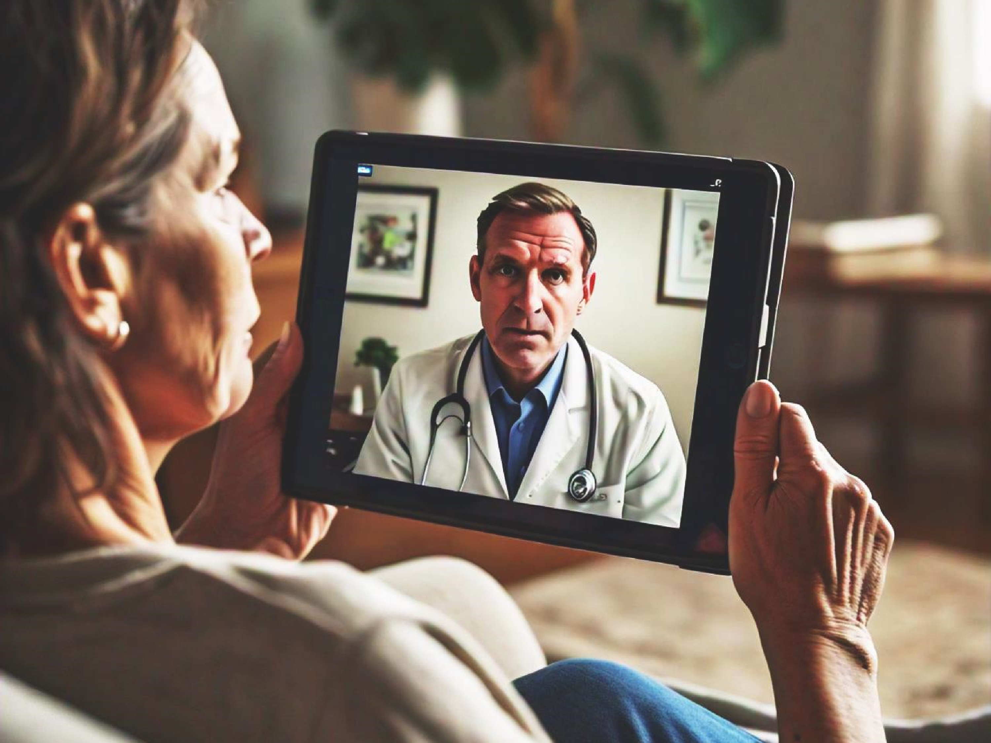

**TELE**

**-**

**DOC**

**A web app platform that provides healthy services remotely to**

**patients to receive medical care from their comfort of their**

**homes.**

# TEAM MATES

* **NAKIRANGWA LETICIA NAKITY 2023/ITB/DAY/1706G**
* **LUBWAMA MARVIN ESUKA 2023/ITB/DAY/0632**
* **MARACTHO JOHN BOSCO 2023/ITB/DAY/1005**
* **KIKULE AUGUSTINE 2023/ITB/DAY/1365**
* **LEPI DENISH 2023/ITB/DAY/0628**
* **KAPERE INNOCENT 2023/ITB/DAY/0939**

## INTRODUCTION

**In to day’s fast-paced world, accessing quality healthcare services can be a daunting task, especially for those living in remote or underserved areas. The traditional model of healthcare delivery often requires patients to travel long distances, wait in queues, and spend variable time and resources. Tele-Doc aims to bridge this gap by leveraging Telemedicine technology to provide convenient, affordable, and high-quality healthcare services to patients anywhere, any time.**

**The Tele-Doc platform will connect patients with licensed healthcare professionals through secure video consultations, enabling remote diagnosis, treatment, and monitoring. By harnessing the power of telemedicine, Tele-Doc seeks to improve health outcomes, enhance patient satisfaction, and reduce healthcare costs. The project outlines the visions, objectives, and key components of the Tele-Doc platform, highlighting its potential to transform the healthcare landscape.**

# BACK GROUND

**The rapid advancement of technology as revolutionized various sectors, and healthcare is no exception. The traditional healthcare models, often characterized by physical clinic visits, are increasingly becoming less efficient and accessible. This particularly true for individuals residing in remote areas, those with mobility limitations, and those with busy schedules. Telemedicine, the delivery of health care services through telecommunication technologies, offers a promising solution to those challenges.**

# PROBLEM STATEMENT

* **Limited access to quality healthcare: Many individuals, especially in rural and underserved areas, face significant barriers to accessing quality healthcare services.**
* **Long wait times: Traditional healthcare systems often involve lengthy wait times for appointments and consultations.**
* **Healthcare costs: The cost of healthcare services, including transportation and time off work, can be prohibitive for many.**

## GENERAL OBJECTIVES

* 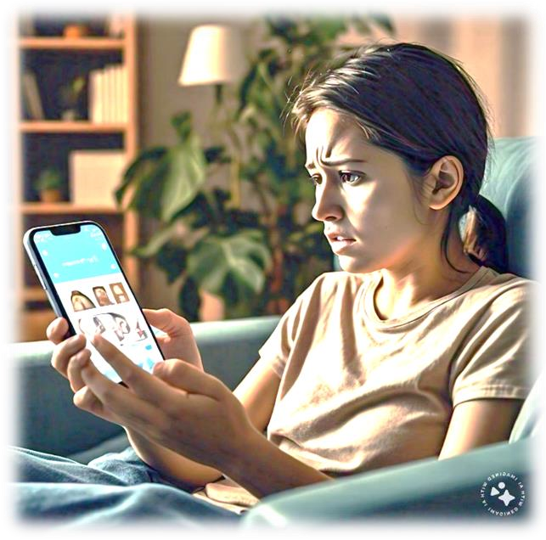Improve access to healthcare: Provide remote access to healthcare services.
* Enhance patient satisfaction: Offer flexible and patient-centered care hence reducing wait times.
* Reduce healthcare costs: Minimize healthcare expenditures by reducing the need for in person visit anda hospitalizations.

## SPECIFIC OBJECTIVES

* **To study and analyse the current system used.**
* **To identify requirements necessary for designing an online doctor-patient interactions system.**
* **To design and develop a user-friendly online platform for managing patient records.**

## SIGNIFICANCE

* **To improve access to healthcare.**
* **To enable cost saving.**
* **To enable scalability and flexibility.**
* **To enable job creation and economic growth.**

## SCOPE

1. **Initial Rollout: Tele-D0c will be launched in a city, with plans to expand to other regions in the future.**
2. **National and International expansion: Tele-Doc aims to expand its services to other countries and regions, subject to regulatory approval and market demand.**
3. **Telemedicine services: Tele-Doc will provide real-time video consultations between patients and healthcare professionals.**
4. **Electronic health records (EHRs) It will integrate with exiting EHR systems to ensure seamless access to patient medical history.**
5. **Prescription management: It will enable health professionals to prescribe medication electronically.**
6. **Laboratory and imaging result: It will allow patients to access their laboratory and imaging results online.**
7. **Platform development: It will be built on a secure, scalable, and user-friendly platform.**
8. **Project timeline: The project is expected to be completed with in one year (12 months).**

## JUSTIFICATION

* Due to aging population, leading to an increased demand for healthcare services.
* Through long wait times, patients often experience long wait times for appointment and treatment.
* By addressing the growing need for accessible and affordable healthcare service.
* By providing remote access to health professionals.

# LITERATURE REVIEW

**Theoretical Review Improve access Cost saving.**

**Enhance patient satisfaction**

▪

▪

▪

▪

▪

**Supporting theory**

**Integration with emerging technologies to enhance it’s effectiveness and efficiency.**

**Personalized medicine to deliver personalized medicine**

## LITERATURE REVIEW

|  |  |
| --- | --- |
| **KEY FEATURES**   Virtual consultations: Patient can consult with boardcertified doctors. | **BENEFITS**   * Increased accessibility * Convenience * Cost effective |

 Prescription management: It allows healthcare professionals to prescribe medications and send them to patients’ local pharmacies

### STATE OF ART/ SIMMILAR SYSTEM

**Recently telemedicine platform have provided virtual consultations, prescription management, and mental health support. Similar systems have been developed such as MDLive, Amwell, plushcare. However, Tele-Doc project is to enable Internet of Thinks (IoT) which integrates with wearable devices and IoT devices to enable remote monitoring and tracking.**

Comparative

EVALUTION

**System type**

**Features**

**Functionality**

**Security**

**Integration**

**with wearable**

**devices**

**costs**

**Quality**

**Customer**

**support**

Teladoc

Yes

Yes

Yes

No

Yes

Yes

Yes

American

well

No

No

No

No

Yes

No

No

MDLive

yes

Yes

Yes

No

Yes

Yes

Yes

Tele

-

Doc

Yes

yes

Yes

yes

yes

yes

Yes

METHODOLOGY

Document review

➢

Reports

➢

Books

Internet research

➢

Study of similar

systems

Data

collection

method



Interviews

➢

Discussions with

patients in the

hospitals

|  |
| --- |
| Consultations   * Patients * Doctors |

**SOFTWARE AND HARD WARE TOOLS**

* Computers
* Smart phones
* Video cameras
* 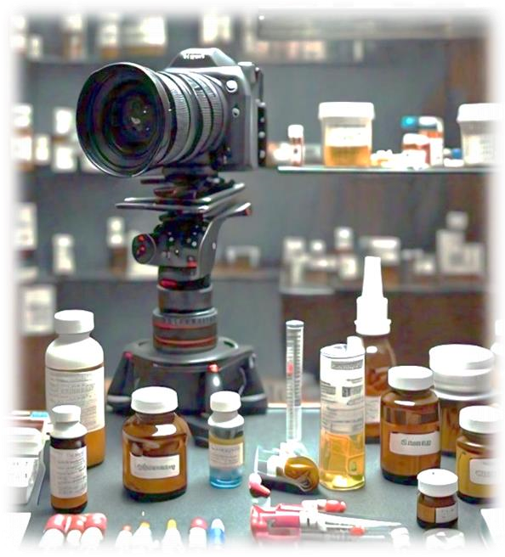Laptop

❖

**SOFTWARE**

* Electronic health records

Video conferencing soft ware

* Data analysis tools
* Telemedicine platform

WORK PLAN/TIMELINE

**Project timeline**

**Months**

**Activity**

**November**

**December**

**March**

**April**

**May**

**June**

Developing research

questions

Finding a problem

Literature review

Proposal submission

Project planning

Project construct

Project

implementation

Project testing

Project presentation

BUDGET

|  |  |  |  |
| --- | --- | --- | --- |
| **PROJECT ESTIMATED BUDGET** | | |  |
| **S/N** | **Item** | **Quantity** | **PRICE (@)** |
| 1 | HARDWARE SERVERS | 1 | 450,000 |
| 2 | DATA STORAGE | 2 | 200,000 |
| 3 | NETWORKING EQUIPMENT | 3 | 100,000 |
| 4 | VIDEO CAMERAS | 2 | 800,000 |
| 5 | AUDIO EQUIPMENT | 2 | 100,000 |
| 6 | ELECTRONIC HEALTH RECORD | 2 | 20,000 |
| 7 | CLOUD SERVICES | 1 | 70,000 |
| 8 | DATA CENTRE SERVICES | 1 | 300,000 |
| 9 | TESTING AND QUALITY ASSURANCE | 1 | 1,000,000 |
|  | **TOTAL** | **15** | **3,040,000** |

# REFERENCES

* Grand View Research(2022). Telemedicine market size, share and trends analysis report.
* American Telemedicine Association (2022)Website.
* Wootton,R.(2012) book, Telemedicine: A guide to assessing telecommunications in health care.
* Kvedar,J.,et al.(2019)Conference proceedings. The future of telemedicine: Emerging trends and technologies
* Journal of medicine internet research
* Doctors
* Patients
* Patient care takers